Ideation Phase

Define the Problem Statements

|  |  |  |  |
| --- | --- | --- | --- |
| Date | 17 October 2022 |  |  |
| Team ID | PNT2022TMID11688 |  |  |
| Pro•ect Name | Containment Zone Alerting Applicaton |  |  |
| Maximum Marks |  |  |  |

Customer Problem Statement Template:

Create a problem statement to understand your customer's point of view. The Customer Problem Statement template helps you focus on what matters to create experiences people will love.

A well-articulated customer problem statement allows you and your team to find the ideal solution for the challenges your customers face. Throughout the process, you'll also be able to empathize with your customers, which helps you better understand how they perceive your product or service.



Example:

Describe the customer and their attributes here

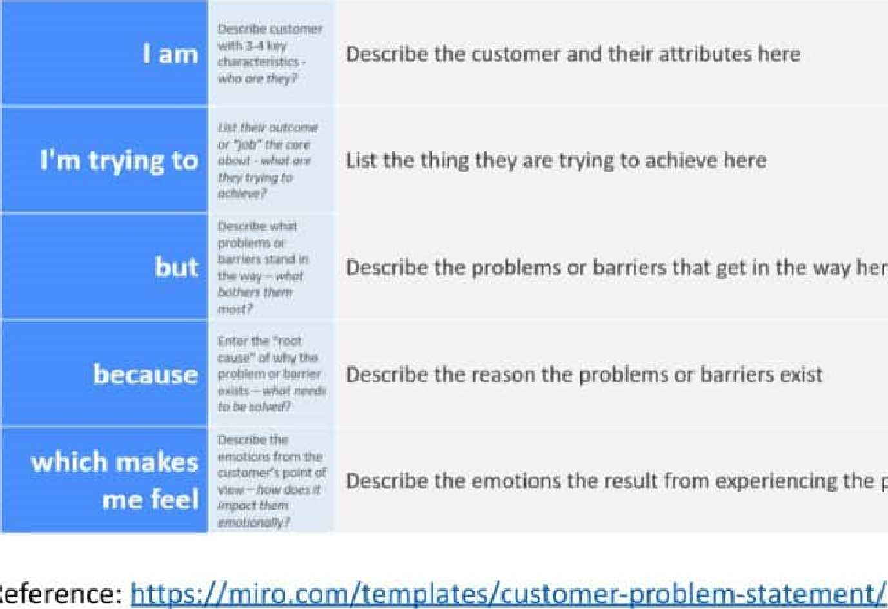

Reference:

List the thing they are trying to achieve here

Describe the problems or barriers that get in the way here

Describe the reason the problems or barriers exist

Describe the emotions the result from experiencing the problems or barriers

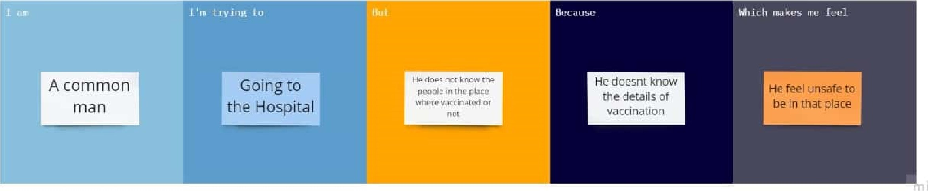

|  |  |  |  |  |  |  |  |  |  |  |  |  |  |
| --- | --- | --- | --- | --- | --- | --- | --- | --- | --- | --- | --- | --- | --- |
| txying to   |  |  |  | | --- | --- | --- | |  | |  | | --- | | Going to foreign country for higher studies | | | But | |  | | --- | | Its so difficult | | Because |  | |  |  |  |  | | --- | --- | --- | --- | |  | |  | | --- | |  | | Scared and frustated | |   Which makes me feel |
|  | of the covid cases not known |
|  |  |

|  |  |  |  |
| --- | --- | --- | --- |
|  | Because | the | Which  makes |
|  |

|  |  |  |  |  |  |  |
| --- | --- | --- | --- | --- | --- | --- |
|  | fTv inc to | 110 t |  | flocausc |  | Whic  h  makos    me    feel |
|  |  |